**DAILY ONLINE ACTIVITIES SUMMARY**

|  |  |  |  |  |  |  |  |  |
| --- | --- | --- | --- | --- | --- | --- | --- | --- |
| **Date:** | 27-06-2020 | | | | | **Name:** | K S Prajwal | |
| **Sem & Sec** | IV A sec | | | | | **USN:** | 4AL18CS032 | |
| **Online Test Summary** | | | | | | | | |
| **Subject** | | DATA COMMUNICATION | | | | | | |
| **Max. Marks** | | 30 | | **Score** | | | 27 | |
| **Certification Course Summary** | | | | | | | | |
| **Course** | Django | | | | | | | |
| **Certificate Provider** | | | Udemy | | **Duration** | | | **3 hr** |
| **Coding Challenges** | | | | | | | | |
| **Problem Statement:**  1:Write a C program to print kth digit | | | | | | | | |
| **Status:** completed | | | | | | | | |
| **Uploaded the report in Github** | | | | | yes | | | |
| **If yes Repository name** | | | | | <https://github.com/alvas-education-foundation/KS_Prajwal> | | | |
| **Uploaded the report in slack** | | | | | yes | | | |

Online Test Details: (Attach the snapshot and briefly write the report for the same)

Certification Course Details: (Attach the snapshot and briefly write the report for the same)

Coding Challenges Details: (Attach the snapshot and briefly write the report for the same)

**Online Test Details: N/A**

Snapshot of certification course:

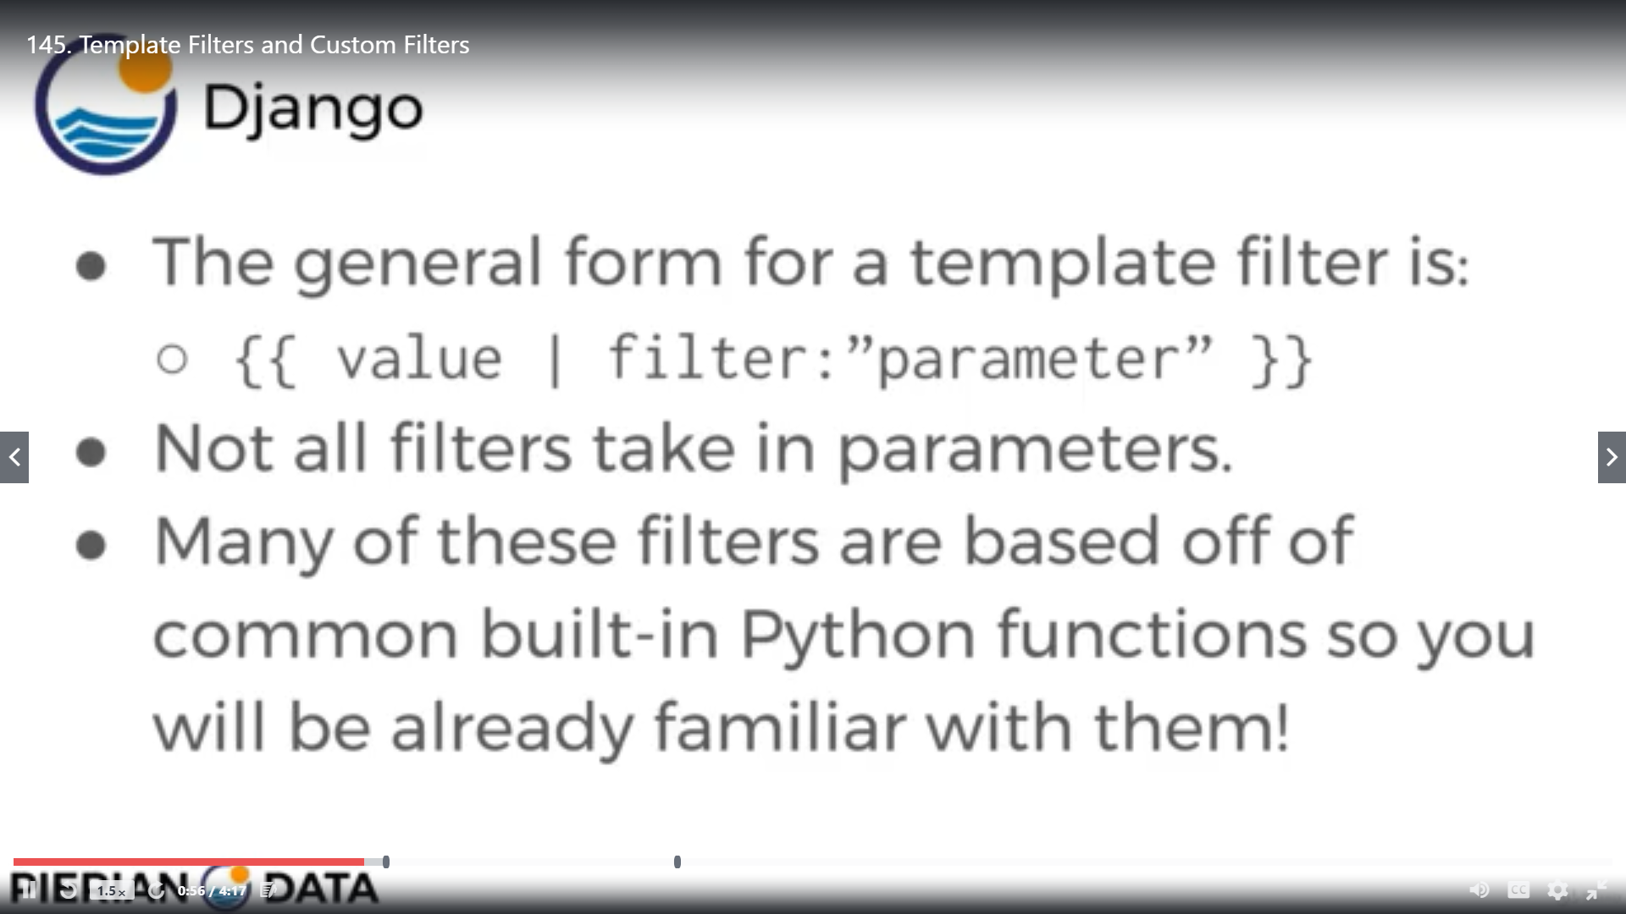

Today was about the templates and applying filters to it and also creating our own custom filters

**Online coding:**

Problem 1:Write a C program to print kth digit

